**PERSONAL BOOK LIBRARY**

**NAME:**VISWATHKUMAR N

**ROLL NO:** 717821F163

**DEPT:** INFORMATION TECHNOLOGY

**CODE:**

**lib.html:**

<!DOCTYPE html>

<html lang="en">

<head>

<meta charset="UTF-8">

<meta name="viewport" content="width=device-width, initial-scale=1.0">

<title>Document</title>

<style>body{

background-color:lightblue;

}

</style>

</head>

<body>

</body>

<script src="jsscript.js"></script>

</html>

**JSSCRIPT.JS:**

function book(){

return{

title:prompt("Enter the title:"),

author:prompt("Enter the author name:"),

yearPublished:+prompt("Enter the year of publishing:"),

readStatus:prompt("Enter your status of reading"),

getSummary:function(){

return "Title: "+this.title+"\nAuthor: "+this.author;

},

toggleReadStatus:function(){

return "Read Status: "+this.readStatus;

}

}}

function book1(){

return {

title:"KGF",

author:"Prasanth Neil",

yearPublished:2018,

readStatus:"read",

}

}

function book2(){

return {

title:"KGF2",

author:"Prasanth Neil",

yearPublished:2022,

readStatus:"read",

}

}

function book3(){

return {

title:"SALAAR",

author:"Prasanth Neil",

yearPublished:2022,

readStatus: "notread",

}

}

function book4(){

return {

title:"MASTER",

author:"Lokesh Kanagaraj",

yearPublished:2021,

readStatus:"read",

}

}

function book5(){

return {

title:"LEO",

author:"Lokesh Kanagaraj",

yearPublished:2023,

readStatus:"notread",

}

}

Library=new Array();

Library.push(book1());

Library.push(book2());

Library.push(book3());

Library.push(book4());

Library.push(book5());

//function to add an book.

function addBook(){

let book1 = book();

Library.push(book1);

}

let n=+prompt("Enter the no of books to add");

for(let i=-0;i<n;i++){

addBook();

}

// Removes the last book from the library using pop()

function removeLastBook(){

Library.pop();

}

//Adds a book to the beginning of the library using unshift().

function addBookToFront(){

let booktofirst=book();

Library.unshift(booktofirst);

}

// Removes the first book from the library using shift().

function removeFirstBook(){

Library.shift();

}

console.log(Library);

// Uses map() to return an array of all book titles in the library.

function getAllTitles(){

let titles = Library.map(na=>na.title);

return titles;

}

// Uses filter() to return books written by a specific author.

function getBooksByAuthor(author1){

let authors = Library.filter(na=>{

if(author1==na.author){

return na.author;

}

});

console.log(authors);

}

// Uses splice() to remove a book with a specific title from the library.

function removebookbytitle(BN){

let lib = Library.findIndex(obj => obj.title===BN);

if(lib!==-1){

Library.splice(lib,1);

}

}

//Uses filter() to return books based on their read status (read or unread).

function getBooksByReadStatus(rs){

let rs1 = Library.filter(obj =>obj.readStatus === rs);

return rs1;

}

// Uses slice() to get a portion of the library.

function getSubLibrary(start,end){

let libslice = Library.slice(start,end);

return libslice;

}

// Uses filter() and reduce() to count how many books were published before a given year.

let counting=0;

let result=[];

function getTotalBooksPublishedBefore(year){

let counter = Library.filter(obj => {

if(obj.yearPublished >= year){

result.push(1);

}

console.log(result);

return result;

} );

counting=result.reduce((sum,result)=>sum+result,0);

console.log("the number of books on and before that year: "+counting);

}

let sc = +prompt("Enter 1 to remove last book\nEnter 2 get books by read status\nEnter 3 to get sub library\nEnter 4 to add book to front\nEnter 5 to get titles of all books\nEnter 6 to get books by author name\nEnter 7 to remove books by title\nEnter 8 to get books by the year");

switch(sc){

case 1:

removeLastBook();

console.log(Library);

break;

case 2:

let rstatus = prompt("Enter your choice of read status:");

console.log(getBooksByReadStatus(rstatus));

break;

case 3:

let start=prompt("Enter the start position:");

let end = prompt("Enter the end position:");

console.log(getSubLibrary(start,end));

break;

case 4:

console.log(addBookToFront());

break;

case 5:

console.log(getAllTitles());

break;

case 6:

let writers= prompt("Enter a Author name:");

console.log(getBooksByAuthor(writers));

break;

case 7:

let Bookname = prompt("Enter the Title to be removed:");

removebookbytitle(Bookname);

console.log(Library);

break;

case 8:

let year = +prompt("Enter the year:");

getTotalBooksPublishedBefore(year);

break;

default:

console.log("Enter a valid case.");

}

**OUTPUT:**

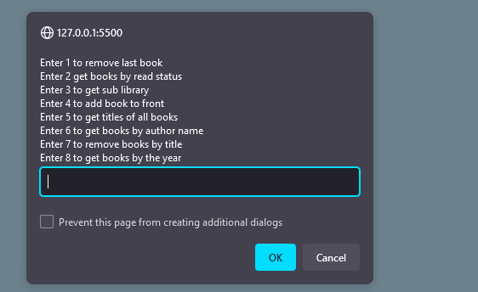

**1.**

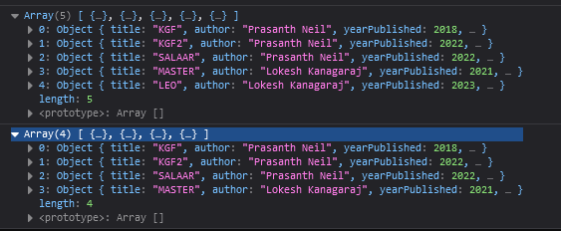

**2.**

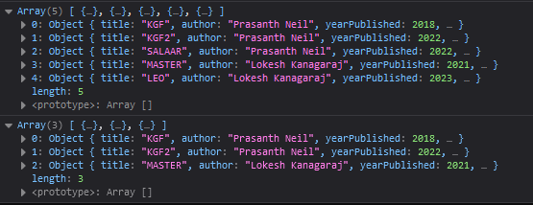

**4.**

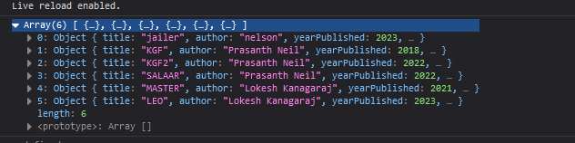

**5.**



**7.**

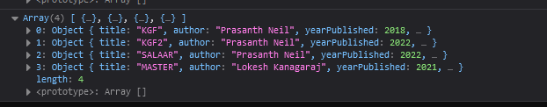

**8.**

